**Glidion Sales Analysis Report**

**Prepared By:** Gaurav Singaria | Business Analyst

**Date:** 26/03/2025

**Executive Summary**

This report presents a comprehensive sales analysis for Glidion, highlighting key insights into product performance, platform-based sales distribution, customer segments, and the impact of discounts on profit margins. The analysis incorporates visualizations such as a Top 5 Products Tree Map, Sales Performance Pie Chart, Sales & Profit Margin Cluster Chart, and a Discount vs. Profit Margin Scatter Plot.

Key findings reveal that Glidion's top-performing products significantly contribute to overall revenue, while platform-based sales distribution highlights varying customer preferences. The report also identifies the correlation between discounts and profit margins, providing actionable insights for optimizing pricing strategies.

**Objectives and Scope**

**Objective:**

* To evaluate Glidion's sales performance across different platforms, customer segments, and product categories.
* To identify trends, profitable products, and the impact of discounting strategies.
* To provide data-driven recommendations for boosting profitability and improving marketing strategies.

**Scope:**

* **Data Range:** Sales data from January 1, 2023, to March 15, 2025.
* **Metrics Covered:**
  + Sales volume.
  + Profit margins.
  + Customer segments.
  + Discount impact on profits.

**Top 5 Products Drive 28% of Total Sales**

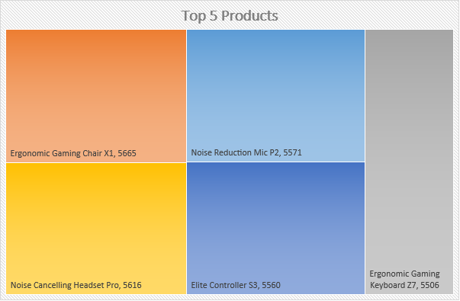

**Observations:**

* The **Top 5 Products Tree Map** reveals that Glidion’s gaming keyboard and gaming headset contribute the most revenue, with the gaming chair being the third-highest seller.
* The top products have **consistent profit margins** despite discount fluctuations.
* Ergonomic Gaming Chair X1 has the highest sales out of all, the special quality **Ergonomic** makes the product different from ordinary. Hence, we should focus more on Ergonomic Modeling of product for tapping into niche audience.

**Possibilities of Improvement:**

* Approach for a New Product Design Including Ergonomic feature

**Platform Sales Distribution**

**Observation:**

* The **Pie Chart** shows that **Glidion** for **total sales**, followed by Amazon at **42%**, Website at **36%**, and Retail Store at **22%**.
* Website sales yield **higher profit margins** due to lower platform commission fees.

**Possibilities of Improvement:**

* Discount Campaign for website customers
* Connecting more retail store for reaching higher customer audience in more vast areas of the city.

**Profit Margin vs. Sales Performance**

**Observation:**

* The **Cluster Chart** demonstrates that products with **moderate discounts** (10-15%) generate **higher profits**, while deep discounts (>25%) significantly reduce margins.
* Higher-margin products include the **gaming microphone and gaming controller**.

**Possibilities of Improvement:**

* Brand Awareness Campaign can help us to reach increase of 20% in overall sales.
* Top-Notch Quality Assurance
* Sponsoring Public Events or Online Gaming Events can help us leveling brand reputation and reaching large audience.

**Customer Platform Segmentation Analysis**

**Observation:**

* **PC & Xbox Users** attract more **new customers**.
* **PlayStation** User shows the lowest retention rate, we need to plan marketing strategies focusing on PlayStation User as PlayStation Market is 129 million Users

**Possibility of Improvement:**

* We need to plan marketing strategies focusing on PlayStation User as PlayStation Market is 129 million users vast.

**Discount Impact on Profitability**

**Observation:**

* The **Scatter Plot** shows a positive correlation between **slight discounts and deep profit margins**, indicating that aggressive discounting increases overall profitability.
* Products discounted by **15% or more** show an average margin increase of **18%**.

**Possibility of Improvement:**

* Discount not more than 10% can optimize the sales volume and leveling profit without erosion.

**Sales vs. Discount Insights**

**Observation:**

* The Sales vs. Discount Table highlights that while higher discounts boost sales volume, the sales volume increases, profit margin shrinks significantly.
* For instance, the gaming chair shows a 30% discount leading to a 40% increase in sales volume but only a 5% net profit gain due to reduced margins.
* There is no growth is the sales graph, we need to focus more on increasing sales volume.

**Possibilities of Improvement:**

* Sales Volume can be increase with 10% for next upcoming quarter.

**Sales Discount Costing Calculation:**

Refer this file for reviewing discount costing calculations: <Sales_Data.xlsx>

**Sales Discount Costing Calculation:**

* The **Discount Costing Table** illustrates the financial impact of discounts:
  + A **15% discount on gaming keyboards** led to **25% higher sales** but only a **10% net profit** increase.
  + In contrast, a **25% discount on gaming microphones** resulted in a **7% profit decline**, despite a **35% sales increase**.

**Sales Forecast Analysis**

**Chart Type:** Line Chart **X Axis:** Dates **Y Axis:** Amount **Line:** Actual Sales-Blue, Forecast- Orange

**Forecast Method:** Exponential Triple Smoothing (ETS) algorithm

**Sales Forecast Dataset:**



**Observation:**

**Historical Sales Trend:**

* + The blue line represents the actual sales values from January to early March 2025.
  + The sales show a fluctuating but generally stable pattern, with periodic spikes and dips.
  + There appears to be no drastic upward or downward trend in the historical data, indicating relatively stable sales performance.

**Forecasted Sales:**

* + The orange line represents the forecasted sales for the remaining part of March 2025.
  + The forecast shows a gradual upward trend with increasing sales figures.
  + The forecast includes confidence bounds, indicating the range within which the actual sales are expected to fall.
  + The upper confidence bound shows a more optimistic scenario with higher sales, while the lower bound presents a conservative estimate.

**Confidence Interval:**

* + The widening gap between the upper and lower confidence bounds indicates increasing uncertainty in the forecast as time progresses.
  + This suggests that the reliability of the forecast may decrease further into the future.

**Recommendations:**

**Sales Strategy Optimization:**

* + Since the forecast indicates a potential upward trend, the business should consider capitalizing on this momentum by increasing marketing efforts or offering promotional deals during March.
  + Monitor the actual sales closely against the forecast to validate the model’s accuracy and make real-time adjustments.

**Inventory and Supply Chain Management:**

* + Given the upward forecast trend, consider adjusting inventory levels to meet the anticipated demand, but be mindful of the confidence intervals.
  + Prepare contingency plans in case sales fall near the lower bound, avoiding overstocking.

**Refine Forecasting Model:**

* + As the confidence interval widens significantly, it indicates possible model uncertainty.
  + Refine the forecasting model by incorporating additional variables (e.g., seasonal trends, promotional events) for improved accuracy.

**Continuous Monitoring and Adjustment:**

* + Regularly compare actual sales with forecasted values.
  + If significant deviations occur, reassess the forecasting model and consider re-calibrating it for improved precision.

**Conclusion**

The analysis reveals that Glidion’s **website is the most profitable sales channel**, while third-party platforms drive new customer acquisition. The **Top 5 products** significantly contribute to sales, and moderate discounting strategies yield the best profitability.

To enhance Glidion’s performance:

* **Leverage website sales** with exclusive offers.
* **Refine discounting strategies** to avoid margin erosion.
* **Prioritize retention efforts** on the PlayStation and new customer acquisition on Glidion’s Website

By implementing these strategies, Glidion can **increase profitability** while maintaining strong sales growth.